NAME: Prasannakumar.P REG NO: 230701238

EXP NO:2

DATA MANIPULATION

Create the following tables with the given structure. EMPLOYEES TABLE

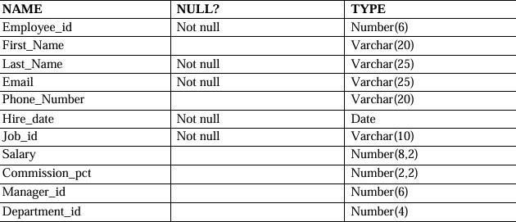

create table employees(employee_id number(6),First_Name varchar(20),Last_Name varchar(25),Email varchar(25),Phone_number varchar(20),hire_date date,Job_id varchar(10),Salary number(8,2),Commission_pct number(2,2),Manager_id

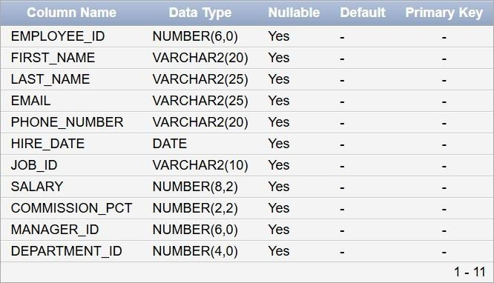

Insert into employees

values(3,'Ralph','Patel','rpatel@gmail.com',9768403822,'11-12-2000',13,5000,.25,101,40);

Insert into employees

values(4,'George','Austin','geaustin@gmail.com',9573268191,'09-10-2018',14,6000,.3,103,60);

Insert into employees values

(1,'Ben','Chad','bchad@gmail.com',9493836325,'24-07-2022',11,4500,.15,100,70);

Insert into employees values

(2,'Bety','Dancs','bdancs@gmail.com',9763467298,'19-05-2021',12,4800,.17,100,56);

Insert into employees values

(5,'Audrey','Austin','audaustin@gmail.com',9684357377,'06-05-2017',15,7000,.35,104,80);

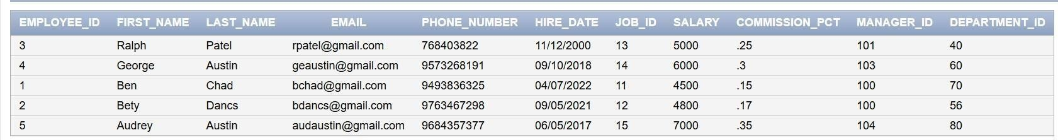

(a) Find out the employee id, names, salaries of all the employees select employee_id,first_name,last_name,salary from employees;

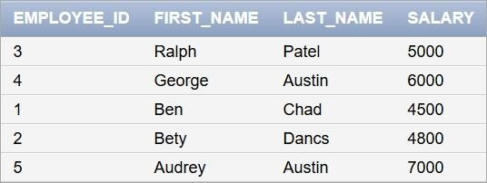

1. List out the employees who works under manager 100 select *from employees where manager_id=100;



1. Find the names of the employees who have a salary greater than or equal to 4800 select first_name,last_name from employees where salary>=4800;

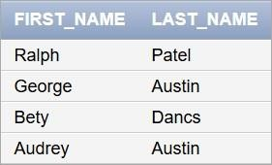

1. List out the employees whose last name is

‗AUSTIN‘ select *from employees where last_name

='Austin';



1. Find the names of the employees who works in departments 60,70 and 80.

select first_name ,last_name from employees where department_id=60 or department_id=70 or department_id=80;

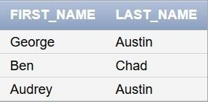

1. Display the unique Manager_Id.

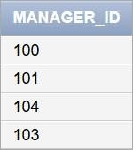

Create an Emp table with the following fields: (EmpNo, EmpName, Job,Basic, DA, HRA,PF, GrossPay, NetPay) (Calculate DA as 30% of Basic and HRA as 40% of Basic) create table emp1(empno number(4),empname varchar(25),job varchar(25),basic number(10),da

number(10),hra number(10),pf number(10),grosspay number(10),netpay number(10));

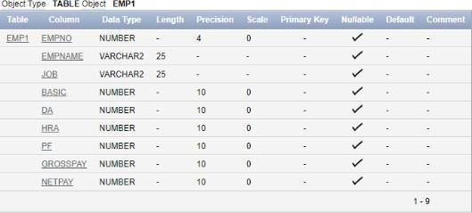

1. Insert Five Records and calculate GrossPay and NetPay.

insert into emp1 values(1,&#39;betty&#39;,&#39;manager&#39;,7000,2100,2800,1000,10,20);

insert into emp1

values(2,&#39;annnie&#39;,&#39;secretary&#39;,5000,1500,2000,1500,20,30); insert into emp1

values(3,&#39;ralph&#39;,&#39;technician&#39;,8000,2400,3200,2000,30,40); insert into emp1 values(4,&#39;linda&#39;,&#39;assistant&#39;,4000,1200,1600,1200,40,50); insert into emp1 values(5,&#39;becky&#39;,&#39;manager&#39;,9000,2700,3600,2500,50,60);

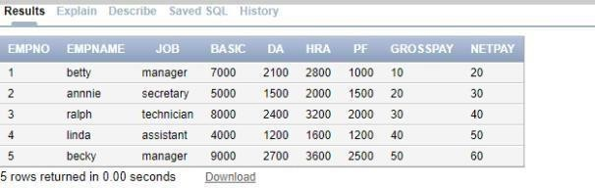

update emp1 set

grosspay=basic+da+hra+ pf; set netpay=basic-pf;

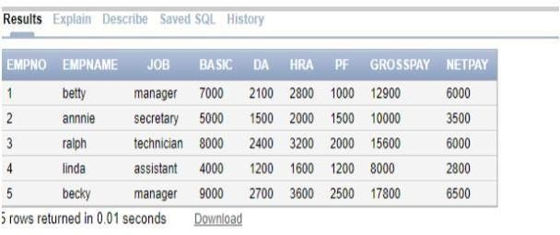

1. Display the employees whose Basic is lowest in each department. select * from emp1 where basic=(select min(basic) from emp1);

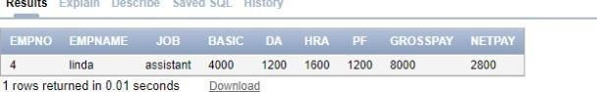

1. If Net Pay is less than select * from

emp1

where netpay=(select min(netpay)from emp1);

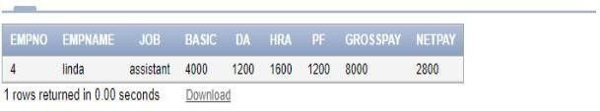

2. Create the EMP table based on the following instance chart. Confirm that the table is created.

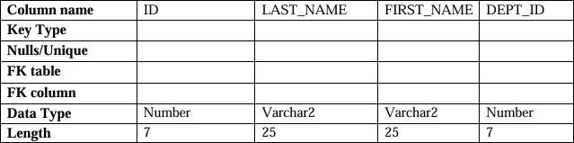

create table emp3(id number(7) primary key not null,last_name varchar2(25) not null,first_name

varchar2(25),dept_id number(7));

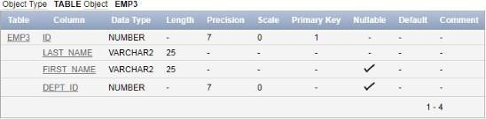

3 Modify the EMP table to allow for longer employee last names. Confirm the modification.(Hint: Increase the size to 50).

alter table emp3 modify last_name varchar2(50);

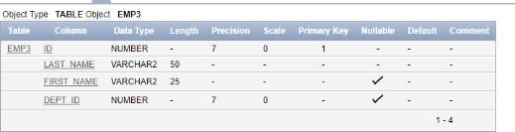

4 Create the EMPLOYEES2 table based on the structure of EMPLOYEES table. Include Only the

Employee_id, First_name, Last_name, Salary and Dept_id coloumns. Name the columns Id, First_name, Last_name, salary and Dept_id respectively.

create table employees2(employee_id number(4),first_name varchar(25),last_name varchar(20),salary number(10),dept_id varchar(5));

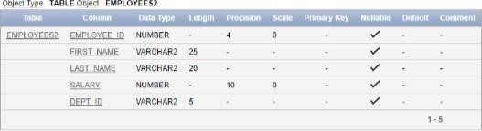

5 Drop the EMP table. drop table emp3;

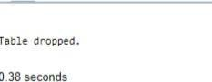

6 Rename the EMPLOYEES2 table as EMP. alter table employees2 rename to emp3;

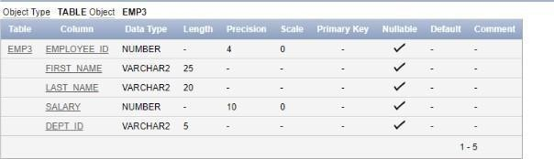

8 Drop the First_name column from the EMP table and confirm it.

alter table emp3 drop column first_name;

